Pearl Ayem – 34404160

**ATSC 303 Lab 12– Upper-Air Measurements**

**Part 1**

1. **Using the data provided in the 2011 Excel spreadsheet (“23Mar2011Sounding.xls”), make a table listing all the significant levels i.e. significant/abrupt changes and extrema in the plotted sounding. Your table should include the height, pressure, temperature, dewpoint temperature, and wind speed and direction at each significant level.**

The following table was generated for the sig points:

|  |  |  |  |  |  |
| --- | --- | --- | --- | --- | --- |
| Pressure (hPa) | Height (m) | Temp (℃) | Temp Dew Point (℃) | Direction (°N) | Windspeed (km/h) |
| 47.9 | 88 | -55.15 | -86.85 | 2 | 1.8 |
| 48.1 | 100 | -54.85 | -85.45 | 2 | 7.56 |
| 52.8 | 121 | -54.65 | -85.25 | 71 | 11.52 |
| 53.7 | 329 | -54.65 | -85.25 | 72 | 13.32 |
| 71.8 | 489 | -54.45 | -84.95 | 78 | 14.04 |
| 72.2 | 492 | -54.45 | -84.95 | 82 | 14.76 |
| 94.7 | 530 | -53.85 | -84.05 | 95 | 16.92 |
| 94.8 | 573 | -52.85 | -84.05 | 112 | 18.72 |
| 126.6 | 797 | -52.35 | -84.05 | 118 | 22.68 |
| 128.7 | 1170 | -52.15 | -84.05 | 119 | 23.4 |
| 149.4 | 1399 | -52.15 | -83.85 | 119 | 24.48 |
| 151.4 | 1472 | -51.95 | -82.55 | 125 | 24.48 |
| 213.2 | 1693 | -51.65 | -82.45 | 126 | 24.84 |
| 219.8 | 1752 | -51.65 | -82.25 | 135 | 24.84 |
| 224.4 | 2081 | -50.55 | -81.15 | 139 | 25.2 |
| 234.9 | 2212 | -50.45 | -80.65 | 139 | 25.2 |
| 265.1 | 2233 | -50.35 | -76.65 | 161 | 25.2 |
| 274.5 | 2656 | -50.35 | -71.45 | 162 | 25.92 |
| 276.8 | 2717 | -50.25 | -69.35 | 162 | 25.92 |
| 280.8 | 3022 | -50.15 | -67.65 | 172 | 25.92 |
| 285.9 | 3355 | -50.05 | -66.85 | 179 | 25.92 |
| 290.4 | 3700 | -48.25 | -65.75 | 179 | 27.72 |
| 336.2 | 4939 | -48.15 | -56.15 | 183 | 28.08 |
| 356.4 | 4972 | -46.45 | -55.55 | 184 | 28.08 |
| 378.1 | 5284 | -43.65 | -55.55 | 184 | 28.08 |
| 404.2 | 5296 | -39.75 | -52.85 | 184 | 28.8 |
| 408.2 | 5451 | -39.15 | -52.35 | 184 | 29.52 |
| 421.1 | 5573 | -37.45 | -50.75 | 186 | 29.52 |
| 433.7 | 5620 | -35.75 | -50.35 | 190 | 29.88 |
| 473.9 | 5788 | -30.85 | -50.15 | 191 | 30.24 |
| 485.3 | 6412 | -29.55 | -47.95 | 191 | 30.6 |
| 488.5 | 6615 | -29.45 | -46.05 | 193 | 30.6 |
| 496.9 | 6829 | -29.05 | -46.05 | 194 | 30.6 |
| 507.7 | 6897 | -27.85 | -45.25 | 195 | 30.96 |
| 508.6 | 7350 | -27.85 | -44.85 | 198 | 30.96 |
| 531.2 | 7743 | -27.85 | -29.95 | 198 | 31.32 |
| 533.6 | 8128 | -27.65 | -29.75 | 199 | 31.68 |
| 631.7 | 9073 | -16.95 | -22.05 | 201 | 32.04 |
| 661.2 | 9172 | -13.85 | -22.05 | 205 | 32.4 |
| 690.6 | 9288 | -11.35 | -16.55 | 205 | 32.4 |
| 718.6 | 9379 | -9.55 | -13.65 | 205 | 32.76 |
| 724.3 | 9433 | -9.15 | -13.45 | 206 | 33.12 |
| 764.8 | 9655 | -6.55 | -12.55 | 208 | 33.12 |
| 766.8 | 10434 | -6.55 | -11.95 | 209 | 33.84 |
| 779.8 | 10728 | -5.65 | -11.55 | 210 | 34.56 |
| 813.1 | 10862 | -3.95 | -11.05 | 212 | 34.92 |
| 819.2 | 11062 | -3.55 | -9.85 | 215 | 36.72 |
| 842.4 | 13305 | -2.15 | -9.55 | 216 | 38.16 |
| 850.2 | 13394 | -1.75 | -9.35 | 216 | 38.16 |
| 875 | 14366 | 0.25 | -9.25 | 217 | 39.96 |
| 916.4 | 14472 | 3.35 | -8.25 | 219 | 40.68 |
| 942 | 16355 | 3.65 | -8.25 | 220 | 40.68 |
| 947 | 16360 | 3.65 | -7.25 | 221 | 43.56 |
| 951.4 | 18115 | 4.35 | -2.35 | 228 | 44.28 |
| 951.8 | 18148 | 4.85 | -2.35 | 229 | 44.28 |
| 970.7 | 20027 | 4.85 | -1.25 | 231 | 44.28 |
| 995.7 | 20139 | 5.05 | -0.85 | 231 | 44.64 |
| 998.3 | 20746 | 5.15 | -0.75 | 231 | 45.36 |
| 999.8 | 20763 | 6.05 | 2.85 | 232 | 48.24 |
| 999.8 | 20844 | 6.05 | 2.85 | 360 | 50.4 |

For visual simplicity, the following plot was constructed using the mandatory and significant points mentioned in this table:

1. **Complete the table of mandatory levels provided in the spreadsheet (it is under a different tab).**

|  |  |  |  |  |  |  |  |  |  |  |  |  |
| --- | --- | --- | --- | --- | --- | --- | --- | --- | --- | --- | --- | --- |
| Time (s) | P (hPa) | Height (m) | T (degC) | TD (degC) | RH (%) | v (m/s) | u (m/s) | DD (degN) | FF (m/s) | FF (km/h) | Lon (degE) | Lon (degN) |
| 2 | 999.1 | 94 | 5.05 | -0.95 | 65 | 1.65 | 2.4 | 235 | 2.9 | 10.44 | -123.24 | 49.25 |
| 236 | 925.2 | 719 | 4.05 | -10.55 | 33 | 0.34 | -8.4 | 92 | 8.4 | 30.24 | -123.25 | 49.25 |
| 498 | 850.2 | 1399 | -1.75 | -11.55 | 47 | 4.14 | -7.39 | 119 | 8.5 | 30.6 | -123.28 | 49.26 |
| 1214 | 699.7 | 2922 | -10.95 | -14.35 | 76 | 6.72 | 0.95 | 188 | 6.8 | 24.48 | -123.31 | 49.3 |
| 2368 | 499.9 | 5408 | -28.75 | -46.75 | 16 | 4.84 | 5.93 | 231 | 7.7 | 27.72 | -123.23 | 49.38 |
| 3076 | 400.1 | 6967 | -40.45 | -48.85 | 41 | 7.76 | 3.65 | 205 | 8.6 | 30.96 | -123.2 | 49.42 |
| 3924 | 300.0 | 8865 | -53.75 | -67.15 | 19 | 12.98 | 8 | 212 | 15.2 | 54.72 | -123.16 | 49.49 |
| 4426 | 250.0 | 10031 | -53.95 | -78.45 | 4 | 10.98 | 1.13 | 186 | 11 | 39.6 | -123.13 | 49.54 |
| 5034 | 200.1 | 11476 | -49.75 | -83.55 | 1 | 11.3 | -2.04 | 170 | 11.5 | 41.4 | -123.12 | 49.59 |
| 5802 | 150.1 | 13364 | -48.45 | -82.75 | 1 | 9.59 | 3.35 | 199 | 10.2 | 36.72 | -123.1 | 49.64 |
| 6798 | 100.0 | 16006 | -51.15 | -84.65 | 1 | 3.64 | 3.45 | 223 | 5 | 18 | -123.06 | 49.7 |
| 7664 | 70.0 | 18311 | -52.85 | -85.85 | 1 | 4.05 | 3.19 | 218 | 5.2 | 18.72 | -123.03 | 49.75 |
| 8490 | 50.0 | 20488 | -51.25 | -84.65 | 1 | 2.69 | -2.78 | 134 | 3.9 | 14.04 | -123.02 | 49.76 |

1. **Plot the dry-bulb and dewpoint temperatures at the mandatory and significant levels (i.e. use the entire data set) on the blank tephigram provided (use a pencil). Use a dot to denote your points plotted at the significant levels, and an open circle to denote your points plotted at the mandatory levels. /10 NOTE: If you are unable to print out the tephigram and plot the points by hand, you can instead open up the PDF in Paint/Powerpoint/whatever other photo or image editor you have, and plot the points using software instead.**
2. **Why do we only plot:** 
   1. **Mandatory levels**

These are reported in to correspond to the standard heights in upper air charts, and make it easy to compare.

* 1. **Significant levels**

Rising rawinsondes record over 5000 rows of data points since they record the weather at approximately ∆z ≈ 5 m increments. To reduce the amount of data transmitted to weather centers, only significant points are reported and straight-line segments are fit in between these significant points.

1. **On your tephigram, clearly mark and label: a. The planetary boundary layer /2 b. The tropopause. /2 Give an explanation for your placement of each.**
2. **Determine the static stability vs. height of the sounding using the nonlocal apex method. Be sure to show your work on the tephigram. /4 HINT: see Background section for resources.**

**Part 2**

1. **Using the data provided in the 2017 Excel spreadsheet (“Sounding23Mar2017.xls”), plot the temperature and dewpoint profiles vs. pressure. Also make a plot with the wind speed profile, and another with the wind direction.**

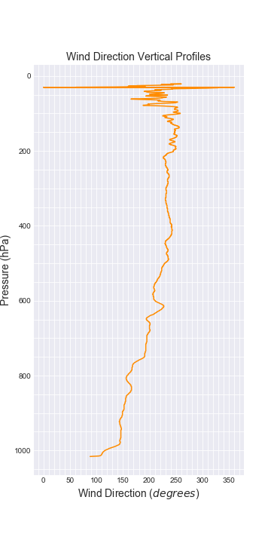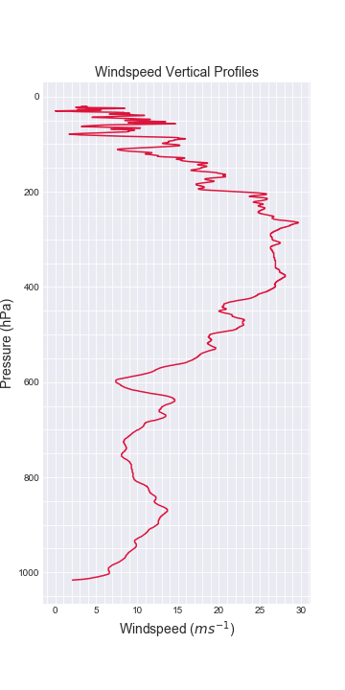

1. **On your temperature/dewpoint plot, mark where the tropopause is, and explain how you made your decision.**

While temperature decreases with height within the troposphere, it is isothermal with height in the bottom part of the stratosphere. This happens starting at approximately 200 hPa in the chart, which I assumed would then be the base of the stratosphere. Therefore, just underneath it, is the tropopause as shown by the dashed line in the chart above.

1. **Find the approximate pressure level of the jet stream.**

I approximated the jet stream at the height of peak windspeed (27.9 ms-1). This occurs at 265.1 hPa as shown in the Windspeed Vertical Profile above.

1. **You should see a temperature inversion at an altitude of about 650 hPa. Does this inversion correspond to the top of the convective mixed layer? Why or why not? Hint: look up what the mixed layer is, if you are not sure.**
2. **Based on your plots from question (1), why do you think we did not ask you to perform a similar analysis with the 2017 data as you did with the 2011 data?**

**Further questions**

1. **Why does the Vaisala RS-90 sonde contain two capacitive humidity sensors?**

It uses 2 sensors to measure relative humidity by heating one sensor to remove potential condensate in supercooled clouds, while the other is used to measure RH. Then, heat is switched to the other sensor and, after the first one cools, it is used to measure RH.

1. **Why would it not be practical to use hair as a humidity sensor in a radiosonde?**

As per Brock Ch.12, Table 12-4, hair has the longest response time for cold temperatures of close to 800s (nearly 13 minutes!) Additionally, hair is brittle and may not withstand high turbulence and winds.

1. **In modern radiosondes, the batteries are surrounded by two small reservoirs of water. Why?**

This is done to reduce cooling as the radiosonde ascends as the water works as an insulator around the battery, and helps maintain performance and efficiency. Additionally, the heat generated by the chemical reaction in the battery is used to compensate the internal cooling of the radiosonde.

1. **Since it is difficult (close to impossible) to prevent exposure errors with a radiosonde, what is the main way that manufacturers help to prevent them?**

The sensors are made as small as possible and the reflectivity is increased